|  |  |  |  |
| --- | --- | --- | --- |
|  | ***For examiners only:*** | | |
| Qn # | Marked by | Mark | Mark checked by |
| 1 | GC |  | AF |
| 2 | GC |  | AF |
| 3 | GC |  | AF |
| 4 | AF |  | GC |
| 5 | AF |  | GC |
| 6 | AF |  | GC |
| **Total** |  |  |  |



# "BSc/MSci Course Unit Examination

***May Assessment Period 2022”***

**CHE206B Pharmaceutical Chemistry**

**Semester B**

Examiners: Dr G. Chianello and Dr A. Fornili

**“Answer all the questions on this paper. The total number of marks available is 80.**

Enter your STUDENT NUMBER here:

|  |  |  |  |  |  |  |  |  |
| --- | --- | --- | --- | --- | --- | --- | --- | --- |
|  |  |  |  |  |  |  |  |  |

Checklist for completion:

☐ If the Dyslexia and Disability Service (DDS) has issued you with a coversheet for use in examinations please attach a copy of this at the start of your answers.

☐ It is recommended that you save your work at least every 15 minutes. Do not risk losing it.

☐ Your submission **MUST** include this front page.

☐ Clearly indicate which question number and part your answers refer to.

☐ To include pictures of your work, such as chemical structures and schemes that you have drawn, please only insert clear but low resolution images, covering only the area needed. Please crop any images to size, to ensure the file size is not too large when submitting.

☐ Name the file using the following format: ModuleCode_StudentNumber, for example CHE206B_190123456.

☐ Do **NOT** include your name in the file name or anywhere within your answer.

You must submit by uploading your answer to QMPlus within 24 hours of the assessment START TIME. Late submissions will not be possible. Ensure you allow plenty of time to upload your work. A back-up copy of your work should be e-mailed as an attachment to the following address: SPCSexams@qmul.ac.uk.

☐ You can only upload one document, once. Resubmissions are **NOT** permitted.

☐ Your answers must be your own work, and you must ensure that you do not break any of the rules in the Academic Misconduct Policy. Please be aware that all submissions will be subject to review, including, but not limited to, analysis by the plagiarism detection software Turnitin.

☐ You will **NOT** be able to view a Turnitin report."

© Queen Mary University of London, 2022

# Question 1

Answer *all* parts.

(a) A series of gastro protectors (**2-7**) have been prepared. The lead compound **1** is shown below. These analogues were classified as being active or inactive in comparison to **1**. Using the information provided, propose a structure for the pharmacophore present in **1**.

Clearly explain your reasoning. [10 *marks*]

## Question 1 continued overleaf

1. Consider the three lead compounds **8**, **9** and **10**, which are being investigated for optimisation in fragment-based drug design. Predict which fragment has the highest

potential for optimisation. Explain your answer. [6 *marks*]

11

1. -log(1.16*10-4)/17 = 0.23

2. 0.28

3. 0.34 this is best as its higher than 0.3

1. Lead compound **11** below undergoes extensive metabolism. Draw two analogues of **11** in

which metabolism is inhibited. [2 *marks*]

1. An optimised analogue of compound **11** is being used as Active Pharmaceutical Ingredient (API) in a tablet. It has been found that the density of the tablet is 0.99 g/mL and the

density of the particulate is 1.1 g/mL. What is the porosity of the tablet? Would this tablet

be prone to cracking or crumbling? Justify your answer. [2 *marks*] **Question 2**

1-(0.99/1.1) = 0.1 it is fine a it is in the 10-20% range

Answer *all* parts.

1. Variation of a substituent **X** in a series of amide derivatives (**12**) led to the Hansch equation shown below. Using the Craig plot and MR table provided (Appendix 1 and 2),

identify the *three* best substituents in order to maximise biological activity. Justify your

choices. [6 *marks*]

log(1/*C*) = -1.20p + 7.88s - 0.26 MR + 0.15

SO2NH3, CONH3 , CH3SO2 there are great as you want a -ve pi to mate 2 -ve into +ve and as well a larger number to make it more potent also you would want a positive sigma that’s also larger to make it potent.

1. An optimised analogue of compound **12** is being used as the API in a suspension.

Assuming the particle radius of this suspension is 650 nm and the particle density variation is 0.5, how many years would it take for these particles to precipitate at 60 oC in water in a container 0.5 dm tall? Show your calculations. (Use Appendix 3 for viscosity values).

[4 *marks*]

0.5dm = 0.05m, 650nm = 650*10-9M, visocity at 60 = 0.000466Pa s

(2/9)*({[ 650*10-9]2*0.5*9.8})/0.000466 = 9.87*10-11

V = d/t, t = d/v 0.05/9.87*10-11 = 506460572.4

506460572.4 / 3.153*107 = 16 Years

# Question 3

The following scheme shows a medicinal chemistry route for the synthesis of compound **13**.

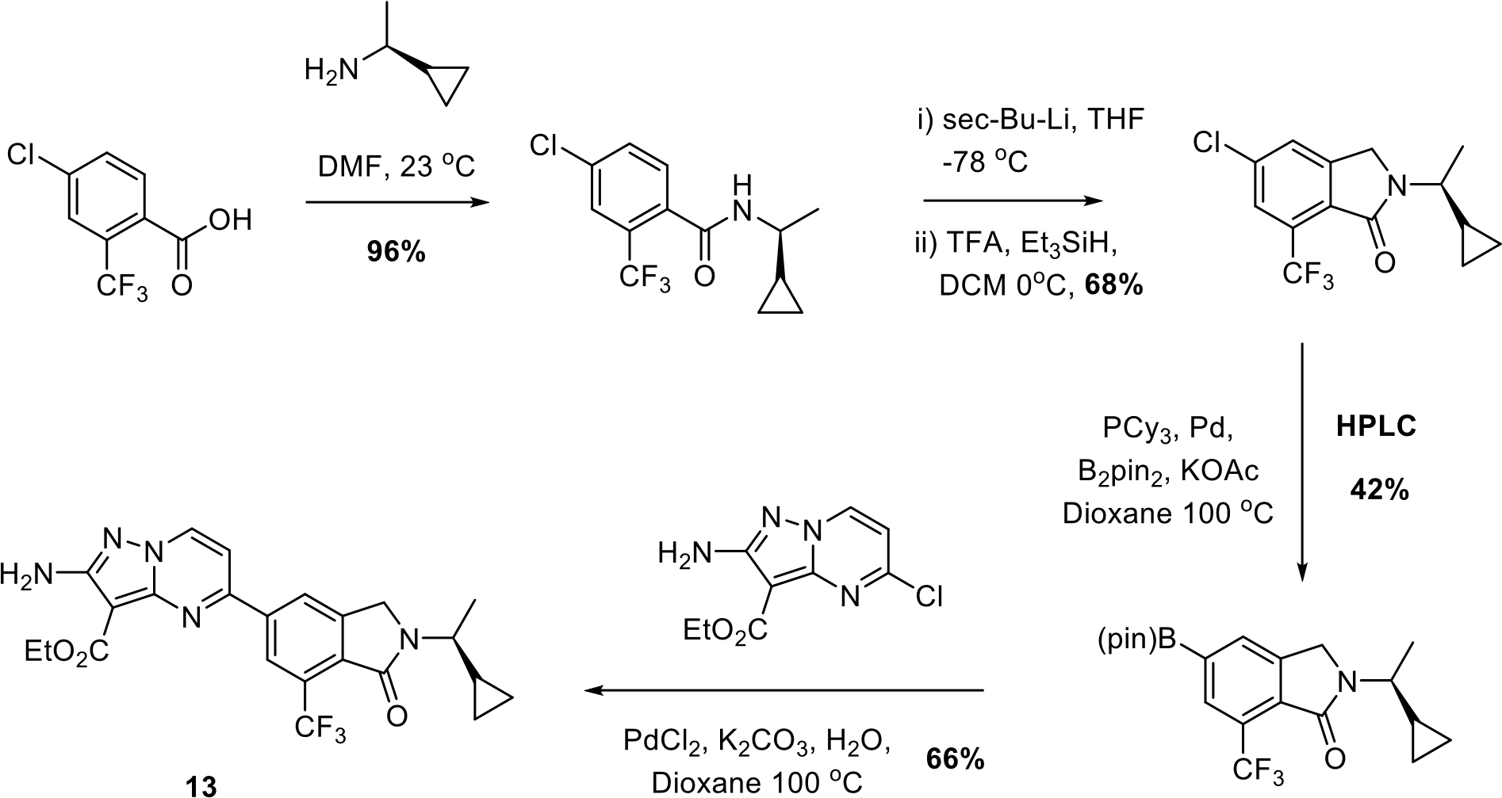

1. The synthesis above has a high Environmental factor (E factor). Identify *two* features of the synthesis above which contribute to the high E factor. Explain your answers. [4 *marks*]

The 3rd and 4th step has the highest as it includes the most waste as seen through the lowert %.

## Question 3 continued overleaf

1. Identify *two* undesirable solvents used in the synthesis and suggest a preferred alternative.

Explain your answer. [2 *marks*]

DMF 🡪 acetonitrile

Dioxane 🡪 TBME

1. Identify *two* logistical challenges of the above synthesis. Explain your answer. [4 *marks*]

# Question 4

The structures of four potential b-blockers (**14**-**17**) are given below:

1. Rank the compounds in order of *increasing* activity as b-blockers. [2 *marks*]

1. For *each* of the four compounds, justify the ranking you have provided in part (a).

[8 *marks*]

17 worst as it is in r conformation it acts as a partial B agonist as well as phenols removed for chlorine which reduces agonistic behaviour

14 has one phenol for hydrogen bonding it has no properties of b agonist or antagonist like ester, alcohol in s config and the amine is primary

16 it has an alcohol in s config as well as a a secondary amine it does have a large head although it has chlorine but it is not para to to the amide has all the properties for an B blocker.

15 it has alcohol in s 2nd amine its branched on the nitrogen

# Question 5

Consider compounds **18**-**21**.

O

N

O

O

N

NH

2

O

**18**

**20**

**21**

**19**

O

N

O

N

O

N

O

OH

1. Comment on the ability of *each* compound to act as a cholinergic agonist or antagonist.

[8 *marks*]

18 is a ok agonist as it has small alkyl group an ester and although it does not have a quaternary amine, 19 is a bad antagonist as its rings are not in the correct position to lock on. 20 is a great antagonist as it has what it is needed. 21 is a good antagonist although one of the branches is a ethyl but since its one it does not matter too much.

1. For each of the compounds identified as having cholinergic activity in part (a), indicate if

they are likely to produce CNS effects. Justify your answer. [2 *marks*] **Question 6**

19, 21 can pass through the BBB as it has a -ve charge on the Nitrogen.

Consider compounds **22**-**25**.

1. A picture containing text, diagram, font

   Description automatically generatedComment on their ability to act as muscle relaxants. [8 *marks*]

Only 23 and 24 are active

1. For each of the compounds identified as muscle relaxants in part (a), indicate if they are

depolarising or non-depolarising. Justify your answer. [4 *marks*]

23 is depolarising as it has small head and 24 is a non depolarising as it has large head groups

1. In a drug optimisation study, a docking calculation was run to generate models of the complex between one of the active compounds and the target receptor.

(i) The docking calculation returned five possible models, which are listed below together with an estimate of the binding affinity between the compound and the target. Which model(s) do you think should be retained for further validation and why?

|  |  |
| --- | --- |
| **Model** | **Binding affinity (kcal/mol)** |
| Model A | -8.3 |
| Model B | 20.3 |
| Model C | 0.5 |
| Model D | -9.2 |
| Model E | -9.0 |

[3 *marks*]

## Question 6 continued overleaf

1. A virtual screening calculation was then run against the 3D-pharmacophore based on one of the docking models. The screening returned six analogues with the following Root Mean Square Deviation (RMSD) values from the 3D pharmacophore:

|  |  |
| --- | --- |
| **Compound** | **RMSD (Å)** |
| A | 0.3 |
| B | 1.2 |
| C | 1.3 |
| D | 0.2 |
| E | 2.4 |
| F | 1.9 |

Which compound(s) do you think should be retained for further validation and why?

[3 *marks*]

1. In some cases, pharmacophore-guided virtual screening might fail to return any analogue. Provide a possible explanation for this and a possible solution. [2 *marks*]

__________________________________________________________________________ **End of Paper. An Appendix of 2 pages follows**

# Appendix 1

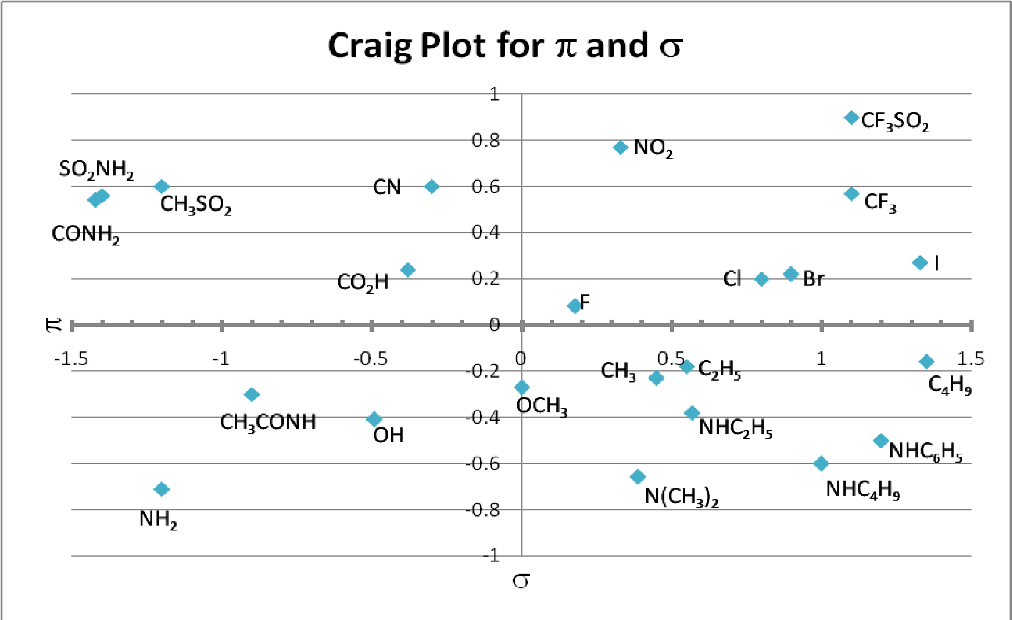

!

# Appendix 2

|  |  |  |  |  |  |
| --- | --- | --- | --- | --- | --- |
| Subst. | MR | Subst. | MR | Subst. | MR |
| **CF3** | 5.02 | **F** | 0.92 | **CN** | 6.33 |
| **Me** | 5.65 | **H** | 1.03 | **CH3SO2** | 14.1 |
| **Et** | 10.3 | **Cl** | 6.03 | **CO2H** | 6.9 |
| **c-Pr** | 13.5 | **Br** | 8.88 | **CH2OH** | 7.2 |
| **i-Pr** | 14.9 | **I** | 13.94 | **CONH2** | 9.8 |
| **n-Pr** | 14.9 | **OH** | 2.85 | **CO2Me** | 12.9 |
| **NHEt** | 18.6 | **OMe** | 7.39 | **NH2** | 5.4 |
| **t-Bu** | 19.6 | **OAc** | 12.47 | **NO2** | 7.4 |
| **Ph** | 25.4 | **OEt** | 12.47 | **NHMe** | 10.3 |
| **NHPh** | 26.7 | **NH-tBu** | 22.3 | **NMe2** | 15.6 |
| **CH3CONH** | 15.6 | **SO2NH2** | 16.9 | **CF3SO2** | 14.8 |

# Appendix 3

|  |  |
| --- | --- |
| **Temperature** | **Dynamic viscosity** |
| **[°C]** | **[Pa s], [N s/m2]** |
| **0.01** | **0.0017914** |
| **10** | **0.001306** |
| **20** | **0.0010016** |
| **25** | **0.00089** |
| **30** | **0.0007972** |
| **40** | **0.0006527** |
| **50** | **0.0005465** |
| **60** | **0.000466** |
| **70** | **0.0004035** |
| **80** | **0.000354** |
| **90** | **0.0003142** |